Nombre Fecha Clase

Describe the following characters from Shrek 2 with three different personality/physical traits!
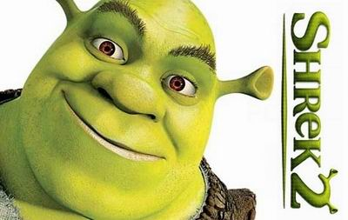
1.
2.
3.
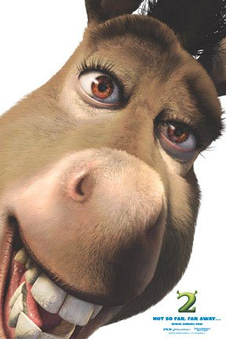
1.
2.
3.


1.
2.
3.
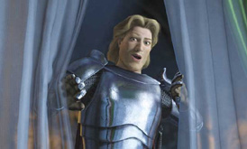
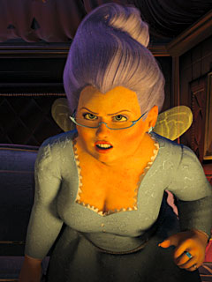

1.
2.
3.

